Q1:login and registration
program
Activity_home.xml
<?xml version="1.0" encoding="utf-8"?>
<android.support.constraint.ConstraintLayout xmlns:android="http://schemas.android.com/apk/res/android"
xmlns:app="http://schemas.android.com/apk/res-auto"
xmlns:tools="http://schemas.android.com/tools"
android:layout_width="match_parent"
android:layout_height="match_parent"
tools:context=".home">

<TextView
android:id="@+id/textView"
android:layout_width="wrap_content"
android:layout_height="wrap_content"
android:text="HOME"
tools:layout_editor_absoluteX="163dp"
tools:layout_editor_absoluteY="40dp" />
</android.support.constraint.ConstraintLayout>
Activity_Main.xml
<?xml version="1.0" encoding="utf-8"?>
<android.support.constraint.ConstraintLayout xmlns:android="http://schemas.android.com/apk/res/android"
xmlns:app="http://schemas.android.com/apk/res-auto"
xmlns:tools="http://schemas.android.com/tools"
android:layout_width="match_parent"
android:layout_height="match_parent"
tools:context=".MainActivity">

<Button
android:id="@+id/btn1"
android:layout_width="100dp"
android:layout_height="51dp"
android:layout_marginTop="24dp"
android:onClick="register"
android:text="Register"
app:layout_constraintEnd_toEndOf="parent"
app:layout_constraintStart_toStartOf="parent"
app:layout_constraintTop_toBottomOf="@+id/btn2" />

<Button
android:id="@+id/btn2"
android:layout_width="79dp"
android:layout_height="wrap_content"
android:layout_marginTop="24dp"
android:layout_marginBottom="24dp"
android:onClick="login"
android:text="Login"
app:layout_constraintBottom_toTopOf="@+id/btn1"
app:layout_constraintEnd_toEndOf="parent"
app:layout_constraintStart_toStartOf="parent"
app:layout_constraintTop_toBottomOf="@+id/edpass" />

<EditText
android:id="@+id/eduname"
android:layout_width="0dp"
android:layout_height="wrap_content"
android:layout_marginTop="24dp"
android:ems="10"
android:hint="username"
android:inputType="textPersonName"
app:layout_constraintEnd_toEndOf="parent"
app:layout_constraintStart_toStartOf="parent"
app:layout_constraintTop_toTopOf="parent" />

<EditText
android:id="@+id/edpass"
android:layout_width="0dp"
android:layout_height="wrap_content"
android:layout_marginTop="24dp"
android:ems="10"
android:hint="password"
android:inputType="textPersonName"
app:layout_constraintEnd_toEndOf="parent"
app:layout_constraintStart_toStartOf="parent"
app:layout_constraintTop_toBottomOf="@+id/eduname" />

</android.support.constraint.ConstraintLayout>
activity_register.xml
<?xml version="1.0" encoding="utf-8"?>
<android.support.constraint.ConstraintLayout xmlns:android="http://schemas.android.com/apk/res/android"
xmlns:app="http://schemas.android.com/apk/res-auto"
xmlns:tools="http://schemas.android.com/tools"
android:layout_width="match_parent"
android:layout_height="match_parent"
tools:context=".register">

<EditText
android:id="@+id/edtxt1"
android:layout_width="0dp"
android:layout_height="wrap_content"
android:layout_marginTop="24dp"
android:layout_marginBottom="24dp"
android:ems="10"
android:hint="Name"
android:inputType="textPersonName"
app:layout_constraintBottom_toTopOf="@+id/edtxt2"
app:layout_constraintEnd_toEndOf="parent"
app:layout_constraintStart_toStartOf="parent"
app:layout_constraintTop_toTopOf="parent" />

<EditText
android:id="@+id/edtxt2"
android:layout_width="0dp"
android:layout_height="wrap_content"
android:layout_marginTop="24dp"
android:layout_marginBottom="24dp"
android:ems="10"
android:hint="Address"
android:inputType="textPersonName"
app:layout_constraintBottom_toTopOf="@+id/edtxt3"
app:layout_constraintEnd_toEndOf="parent"
app:layout_constraintStart_toStartOf="parent"
app:layout_constraintTop_toBottomOf="@+id/edtxt1" />

<EditText
android:id="@+id/edtxt3"
android:layout_width="0dp"
android:layout_height="wrap_content"
android:layout_marginBottom="24dp"
android:ems="10"
android:hint="email"
android:inputType="textPersonName"
app:layout_constraintBottom_toTopOf="@+id/edtxt4"
app:layout_constraintEnd_toEndOf="parent"
app:layout_constraintStart_toStartOf="parent" />

<EditText
android:id="@+id/edtxt4"
android:layout_width="0dp"
android:layout_height="wrap_content"
android:layout_marginTop="24dp"
android:ems="10"
android:hint="phone no"
android:inputType="textPersonName"
app:layout_constraintEnd_toEndOf="parent"
app:layout_constraintStart_toStartOf="parent"
app:layout_constraintTop_toBottomOf="@+id/edtxt3" />
</android.support.constraint.ConstraintLayout>
home.java
package com.example.sjcet.constlayout;

import android.support.v7.app.AppCompatActivity;
import android.os.Bundle;

public class home extends AppCompatActivity {

@Override
protected void onCreate(Bundle savedInstanceState) {
super.onCreate(savedInstanceState);
setContentView(R.layout.activity_home);
}
}
Main_Activity.java
package com.example.sjcet.constlayout;

import android.content.Intent;
import android.support.v7.app.AppCompatActivity;
import android.os.Bundle;
import android.view.View;
import android.widget.EditText;
import android.widget.Toast;

public class MainActivity extends AppCompatActivity {

@Override
protected void onCreate(Bundle savedInstanceState) {
super.onCreate(savedInstanceState);
setContentView(R.layout.activity_main);
}

public void register(View view) {
Intent i = new Intent(MainActivity.this, register.class);
startActivity(i);
}

public void login(View view) {
EditText E1, E2;
E1 =(EditText) findViewById(R.id.eduname);
E2 = (EditText) findViewById(R.id.edpass);

if ((E1.getText().toString().equals("admin")) && (E2.getText().toString().equals("admin")))
{
Intent i = new Intent(MainActivity.this,home.class);
startActivity(i);
}

else
{
Toast.makeText(this, "Invalid username or password", Toast.LENGTH_SHORT).show();
}

}
}
Register.java
package com.example.sjcet.loginvali;

import android.support.v7.app.AppCompatActivity;
import android.os.Bundle;
import android.view.View;
import android.widget.EditText;
import android.widget.Toast;

public class register extends AppCompatActivity {

@Override
protected void onCreate(Bundle savedInstanceState) {
super.onCreate(savedInstanceState);
setContentView(R.layout.activity_register);
}

public void rgstr(View view) {
EditText E1,E2,E3,E4,E5;
E1 = (EditText) findViewById(R.id.edtxt1);
E2 = (EditText) findViewById(R.id.edtxt2);
E3 = (EditText) findViewById(R.id.edtxt3);
E4 = (EditText) findViewById(R.id.edtxt4);
E5 = (EditText) findViewById(R.id.edtxt5);

String MobilePattern = "[0-9]{10}";

if(E1.length() == 0) {
Toast.makeText(this, "Enter name", Toast.LENGTH_SHORT).show();
}

else if(E2.length() == 0) {
Toast.makeText(this, "Enter Address", Toast.LENGTH_SHORT).show();
}

else if(E3.length() == 0) {
Toast.makeText(this, "Enter Email", Toast.LENGTH_SHORT).show();
}

else if(E4.length() == 0) {
Toast.makeText(this, "Enter phone no", Toast.LENGTH_SHORT).show();
}
else if((E4.length() != 10) && (!E5.getText().toString().matches(MobilePattern)) ) {
Toast.makeText(this, "enter valid phone number", Toast.LENGTH_SHORT).show();
}

else if(E5.length() == 0) {
Toast.makeText(this, "Enter valid password", Toast.LENGTH_SHORT).show();
}
else if(E5.length() < 8) {
Toast.makeText(this, "Password should be minimum 8 characters", Toast.LENGTH_SHORT).show();
}
else{
Toast.makeText(this, "resgistered successfully", Toast.LENGTH_SHORT).show();
}

}
}

output

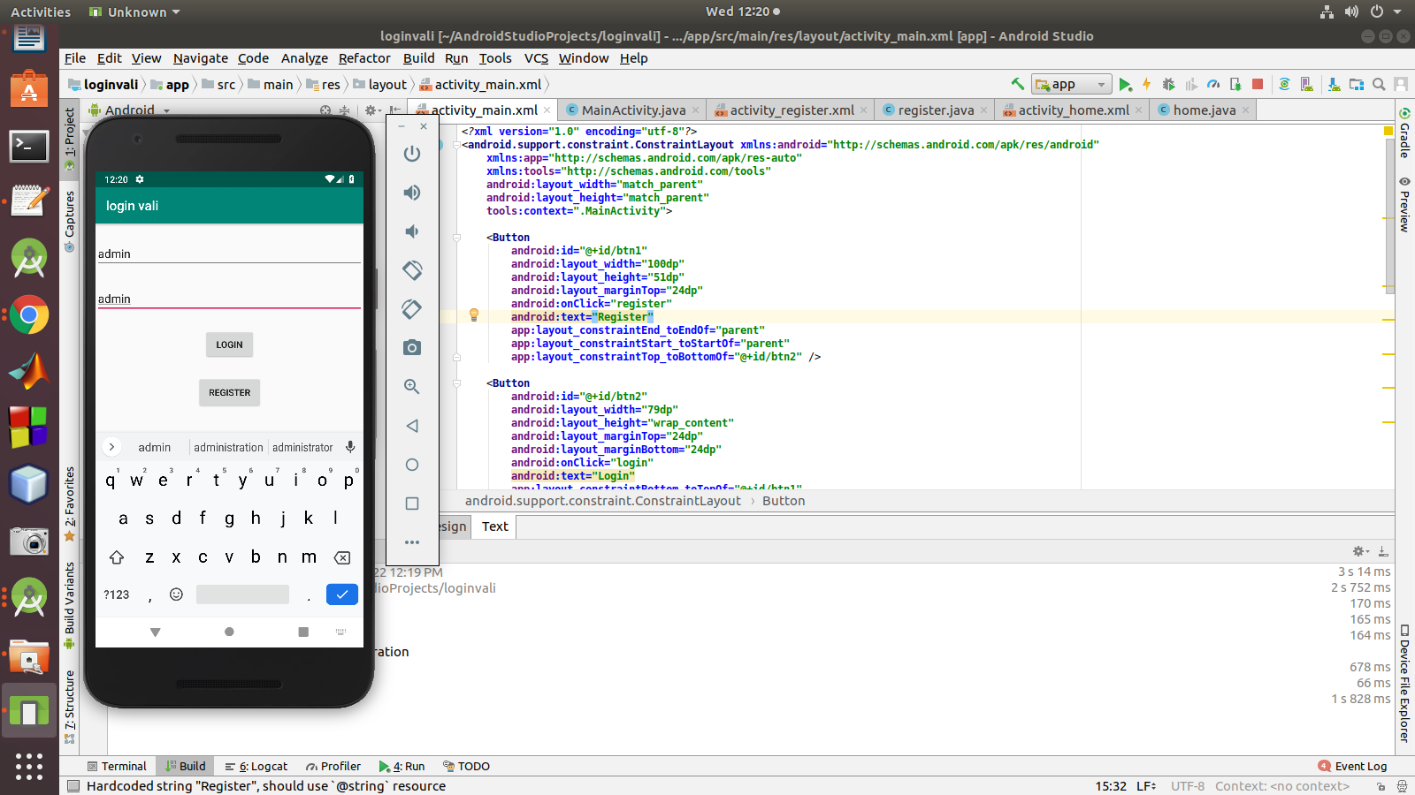
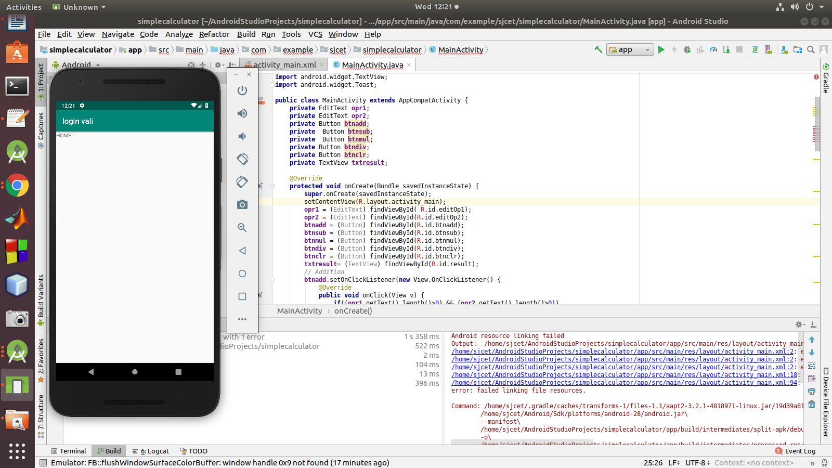

Q2:SIMPLE CALCULATOR
Activity_Main.xml
<?xml version="1.0" encoding="utf-8"?>
<android.support.constraint.ConstraintLayout xmlns:android="http://schemas.android.com/apk/res/android"
xmlns:app="http://schemas.android.com/apk/res-auto"
xmlns:tools="http://schemas.android.com/tools"
android:layout_width="match_parent"
android:layout_height="match_parent"
tools:context=".MainActivity">

<TextView
android:id="@+id/textView"
android:layout_width="match_parent"
android:layout_height="wrap_content"
android:layout_marginStart="8dp"
android:layout_marginLeft="8dp"
android:layout_marginTop="16dp"
android:layout_marginEnd="8dp"
android:layout_marginRight="8dp"
android:layout_marginBottom="8dp"
android:text="CALCULATOR"
android:textAlignment="center"
android:textSize="36dp"
android:textStyle="bold"
app:layout_constraintBottom_toTopOf="@+id/E1"
app:layout_constraintEnd_toEndOf="parent"
app:layout_constraintStart_toStartOf="parent"
app:layout_constraintTop_toTopOf="parent" />

<EditText
android:id="@+id/E1"
android:layout_width="match_parent"
android:layout_height="wrap_content"
android:layout_marginStart="8dp"
android:layout_marginLeft="8dp"
android:layout_marginTop="8dp"
android:layout_marginEnd="8dp"
android:layout_marginRight="8dp"
android:layout_marginBottom="8dp"
android:hint="Enter The first Number:"
app:layout_constraintBottom_toTopOf="@+id/E2"
app:layout_constraintEnd_toEndOf="parent"
app:layout_constraintStart_toStartOf="parent"
app:layout_constraintTop_toBottomOf="@+id/textView" />

<EditText
android:id="@+id/E2"
android:layout_width="match_parent"
android:layout_height="wrap_content"
android:layout_marginStart="8dp"
android:layout_marginLeft="8dp"
android:layout_marginTop="8dp"
android:layout_marginEnd="8dp"
android:layout_marginRight="8dp"
android:layout_marginBottom="8dp"
android:hint="Enter The Second Number:"
app:layout_constraintBottom_toTopOf="@+id/E3"
app:layout_constraintEnd_toEndOf="parent"
app:layout_constraintStart_toStartOf="parent"
app:layout_constraintTop_toBottomOf="@+id/E1" />

<EditText
android:id="@+id/E3"
android:layout_width="match_parent"
android:layout_height="wrap_content"
android:layout_marginStart="8dp"
android:layout_marginLeft="8dp"
android:layout_marginTop="8dp"
android:layout_marginEnd="8dp"
android:layout_marginRight="8dp"
android:layout_marginBottom="8dp"
android:text=""
app:layout_constraintBottom_toTopOf="@+id/B1"
app:layout_constraintEnd_toEndOf="parent"
app:layout_constraintStart_toStartOf="parent"
app:layout_constraintTop_toBottomOf="@+id/E2" />

<Button
android:id="@+id/B1"
android:layout_width="80dp"
android:layout_height="wrap_content"
android:layout_marginStart="8dp"
android:layout_marginLeft="8dp"
android:layout_marginTop="16dp"
android:layout_marginEnd="8dp"
android:layout_marginRight="8dp"
android:layout_marginBottom="8dp"
android:text="+"
android:textSize="30dp"
android:textStyle="bold"
app:layout_constraintBottom_toTopOf="@+id/B3"
app:layout_constraintEnd_toStartOf="@+id/B2"
app:layout_constraintStart_toStartOf="parent"
app:layout_constraintTop_toBottomOf="@+id/E3" />

<Button
android:id="@+id/B2"
android:layout_width="80dp"
android:layout_height="wrap_content"
android:layout_marginTop="20dp"
android:layout_marginEnd="44dp"
android:layout_marginRight="44dp"
android:text="-"
android:textSize="30dp"
android:textStyle="bold"
app:layout_constraintEnd_toStartOf="@+id/B5"
app:layout_constraintTop_toBottomOf="@+id/E3" />

<Button
android:id="@+id/B3"
android:layout_width="80dp"
android:layout_height="wrap_content"
android:layout_marginStart="8dp"
android:layout_marginLeft="8dp"
android:layout_marginTop="8dp"
android:layout_marginEnd="8dp"
android:layout_marginRight="8dp"
android:text="*"
android:textSize="30dp"
android:textStyle="bold"
app:layout_constraintEnd_toStartOf="@+id/B2"
app:layout_constraintStart_toStartOf="parent"
app:layout_constraintTop_toBottomOf="@+id/B1" />

<Button
android:id="@+id/B4"
android:layout_width="80dp"
android:layout_height="wrap_content"
android:layout_marginStart="8dp"
android:layout_marginLeft="8dp"
android:layout_marginTop="12dp"
android:layout_marginEnd="8dp"
android:layout_marginRight="8dp"
android:text="/"
android:textSize="30dp"
android:textStyle="bold"
app:layout_constraintEnd_toStartOf="@+id/B5"
app:layout_constraintHorizontal_bias="0.485"
app:layout_constraintStart_toEndOf="@+id/B3"
app:layout_constraintTop_toBottomOf="@+id/B2" />

<Button
android:id="@+id/B5"
android:layout_width="80dp"
android:layout_height="132dp"
android:layout_marginTop="16dp"
android:layout_marginEnd="16dp"
android:layout_marginRight="16dp"
android:text="="
android:textSize="30dp"
android:textStyle="bold"
app:layout_constraintEnd_toEndOf="parent"
app:layout_constraintTop_toBottomOf="@+id/E3" />
</android.support.constraint.ConstraintLayout>
Main_Activity.java
package com.example.sjcet.calcconstraint;

import android.support.v7.app.AppCompatActivity;
import android.os.Bundle;
import android.view.View;
import android.widget.Button;
import android.widget.EditText;

public class MainActivity extends AppCompatActivity {

Button b1,b2,b3,b4,b5,b6;
EditText e1,e2,e3;
double ans;

@Override
protected void onCreate(Bundle savedInstanceState) {
super.onCreate(savedInstanceState);
setContentView(R.layout.activity_main);

b1 = (Button) findViewById(R.id.B1);
b2 = (Button) findViewById(R.id.B2);
b3 = (Button) findViewById(R.id.B3);
b4 = (Button) findViewById(R.id.B4);
b5 = (Button) findViewById(R.id.B5);
e1 = (EditText) findViewById(R.id.E1);
e2 = (EditText) findViewById(R.id.E2);
e3 = (EditText) findViewById(R.id.E3);

b1.setOnClickListener(new View.OnClickListener() {
@Override
public void onClick(View v) {
double a=Double.parseDouble(e1.getText().toString());
double b=Double.parseDouble((e2.getText().toString()));
ans=a+b;
}
});
b2.setOnClickListener(new View.OnClickListener() {
@Override
public void onClick(View v) {
double a=Double.parseDouble((e1.getText().toString()));
double b=Double.parseDouble((e2.getText().toString()));
ans=a-b;
}
});
b3.setOnClickListener(new View.OnClickListener() {
@Override
public void onClick(View v) {
double a=Double.parseDouble(e1.getText().toString());
double b=Double.parseDouble((e2.getText().toString()));
ans=a*b;
}
});
b4.setOnClickListener(new View.OnClickListener() {
@Override
public void onClick(View v) {
double a=Double.parseDouble(e1.getText().toString());
double b=Double.parseDouble(e2.getText().toString());
if(b!=0)
ans=a/b;
}
});
b5.setOnClickListener(new View.OnClickListener() {
@Override
public void onClick(View v) {
String ans1=String.valueOf(ans);
e3.setText(ans1);
ans=0;
}
});

}
}
Q3:using intent content change to next page
Activity_Main.xml
<?xml version="1.0" encoding="utf-8"?>
<LinearLayout xmlns:android="http://schemas.android.com/apk/res/android"
xmlns:tools="http://schemas.android.com/tools"
android:layout_width="match_parent"
android:layout_height="match_parent"
android:padding="15dp"
tools:context="com.androidexample.First"
android:orientation="vertical">

<EditText
android:layout_width="match_parent"
android:layout_height="wrap_content"
android:id="@+id/textBox"
android:hint="Enter Your Message"/>

<Button
android:layout_width="match_parent"
android:layout_height="wrap_content"
android:id="@+id/passButton"
android:text="Pass"/>
</LinearLayout>
Activity_Main2.xml
<?xml version="1.0" encoding="utf-8"?>
<LinearLayout xmlns:android="http://schemas.android.com/apk/res/android"
xmlns:tools="http://schemas.android.com/tools"
android:layout_width="match_parent"
android:layout_height="match_parent"
android:padding="15dp"
tools:context="com.androidexample.Second">

<TextView
android:layout_width="match_parent"
android:layout_height="wrap_content"
android:text=""
android:id="@+id/text"/>
</LinearLayout>
Main_Activity.java
package com.example.sjcet.p3intentmessagepass;
import android.content.Intent;
import android.support.v7.app.AppCompatActivity;
import android.os.Bundle;
import android.view.View;
import android.widget.Button;
import android.widget.EditText;

public class MainActivity extends AppCompatActivity {
EditText textBox;
Button passButton;

@Override
protected void onCreate(Bundle savedInstanceState) {
super.onCreate(savedInstanceState);
setContentView(R.layout.activity_main);

textBox = (EditText)findViewById(R.id.textBox);
passButton = (Button)findViewById(R.id.passButton);

passButton.setOnClickListener(new View.OnClickListener() {
@Override
public void onClick(View v) {
String str = textBox.getText().toString();

Intent intent = new Intent(getApplicationContext(),Main2Activity.class);
intent.putExtra("message", str);

startActivity(intent);
}
});
}
}
Main_Activity2.java
package com.example.sjcet.p3intentmessagepass;

import android.content.Intent;
import android.support.v7.app.AppCompatActivity;
import android.os.Bundle;
import android.widget.TextView;

public class Main2Activity extends AppCompatActivity {
TextView text;

@Override
protected void onCreate(Bundle savedInstanceState) {
super.onCreate(savedInstanceState);
setContentView(R.layout.activity_main2);

text = (TextView) findViewById(R.id.text);

Intent intent = getIntent();
String str = intent.getStringExtra("message");
text.setText(str);
}
}

Q4:LIST VIEW
PROGRAM
Main_activity
package com.example.sjcet.listview;
import android.support.v7.app.AppCompatActivity;
import android.os.Bundle;
import android.widget.ArrayAdapter;
import android.widget.ListView;
public class MainActivity extends AppCompatActivity {
ListView lv;
@Override
protected void onCreate(Bundle savedInstanceState) {
super.onCreate(savedInstanceState);
setContentView(R.layout.activity_main);
lv=(ListView)findViewById(R.id.lv);
String[] courses={"MCA","MBA","BBA","BCA"};
ArrayAdapter adapter = new ArrayAdapter(this,android.R.layout.simple_list_item_1,courses);
lv.setAdapter(adapter);
}
}
Activity.xml
<?xml version="1.0" encoding="utf-8"?>
<android.support.constraint.ConstraintLayout xmlns:android="http://schemas.android.com/apk/res/android"
xmlns:app="http://schemas.android.com/apk/res-auto"
xmlns:tools="http://schemas.android.com/tools"
android:layout_width="match_parent"
android:layout_height="match_parent"
tools:context=".MainActivity">
<TextView
android:id="@+id/textView2"
android:layout_width="wrap_content"
android:layout_height="wrap_content"
app:layout_constraintBottom_toBottomOf="parent"
app:layout_constraintLeft_toLeftOf="parent"
app:layout_constraintRight_toRightOf="parent"
app:layout_constraintTop_toTopOf="parent" />
<TextView
android:id="@+id/textView"
android:layout_width="162dp"
android:layout_height="47dp"
android:layout_marginStart="8dp"
android:layout_marginLeft="8dp"
android:layout_marginEnd="8dp"
android:layout_marginRight="8dp"
android:text="Account"
app:layout_constraintEnd_toEndOf="parent"
app:layout_constraintStart_toStartOf="parent"
tools:layout_editor_absoluteY="64dp" />
<ListView
android:id="@+id/lv"
android:layout_width="368dp"
android:layout_height="321dp"
tools:layout_editor_absoluteX="8dp"
tools:layout_editor_absoluteY="131dp" />
</android.support.constraint.ConstraintLayolistut>
OUTPUT
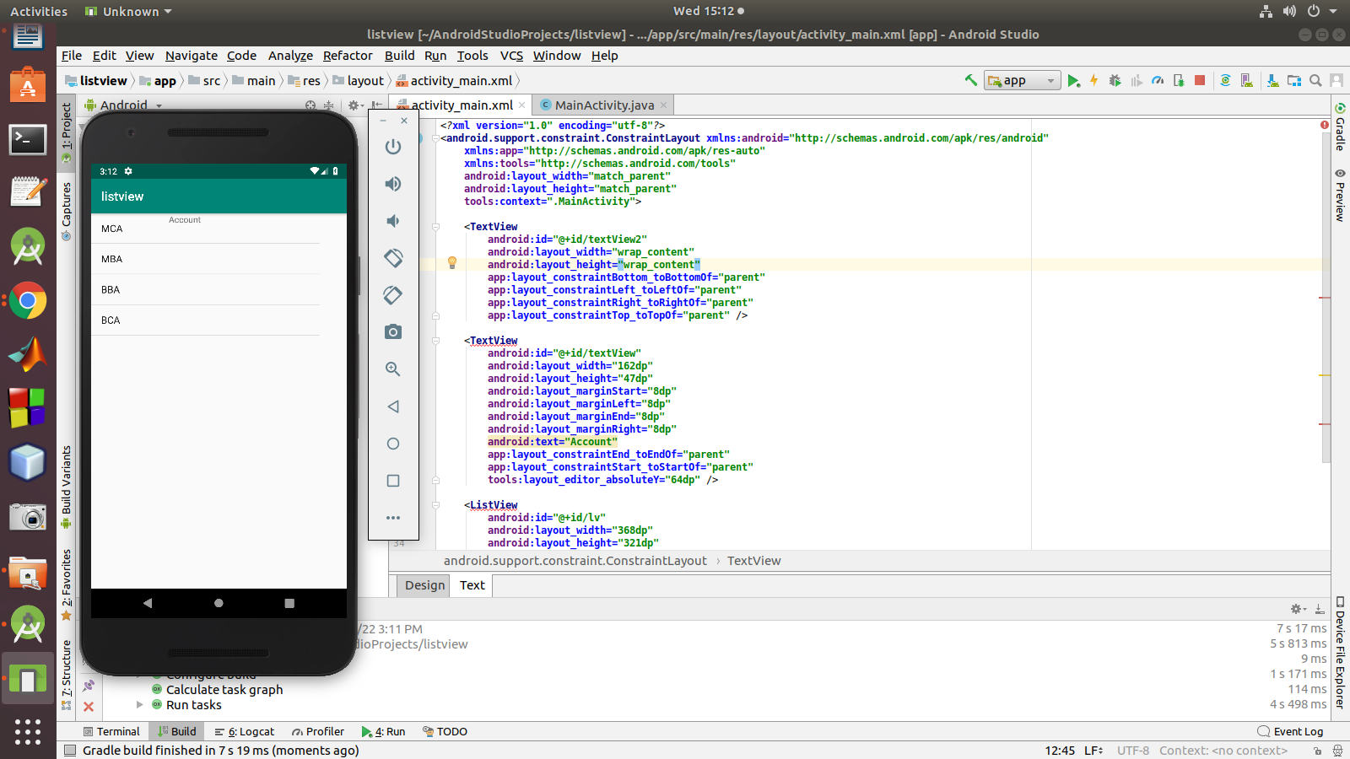

Q5:List View using Toast
program
Activity_Main.xml
<?xml version="1.0" encoding="utf-8"?>
<android.support.constraint.ConstraintLayout xmlns:android="http://schemas.android.com/apk/res/android"
xmlns:app="http://schemas.android.com/apk/res-auto"
xmlns:tools="http://schemas.android.com/tools"
android:layout_width="match_parent"
android:layout_height="match_parent"
tools:context=".MainActivity">
<TextView
android:id="@+id/textView2"
android:layout_width="wrap_content"
android:layout_height="wrap_content"
app:layout_constraintBottom_toBottomOf="parent"
app:layout_constraintLeft_toLeftOf="parent"
app:layout_constraintRight_toRightOf="parent"
app:layout_constraintTop_toTopOf="parent" />
<TextView
android:id="@+id/tv"
android:layout_width="162dp"
android:layout_height="47dp"
android:layout_marginStart="8dp"
android:layout_marginLeft="8dp"
android:layout_marginEnd="8dp"
android:layout_marginRight="8dp"
android:text="Account"
app:layout_constraintEnd_toEndOf="parent"
app:layout_constraintStart_toStartOf="parent"
tools:layout_editor_absoluteY="64dp" />
<ListView
android:id="@+id/lv"
android:layout_width="368dp"
android:layout_height="321dp"
tools:layout_editor_absoluteX="8dp"
tools:layout_editor_absoluteY="131dp" />
</android.support.constraint.ConstraintLayout>
Main_Activity.java
package com.example.sjcet.tostlistview;
import android.content.Intent;
import android.net.Uri;
import android.support.v7.app.AppCompatActivity;
import android.os.Bundle;
import android.view.Menu;
import android.view.MenuItem;
import android.view.View;
import android.widget.AdapterView;
import android.widget.ArrayAdapter;
import android.widget.ListView;
import android.widget.TextView;
import android.widget.Toast;
public class MainActivity extends AppCompatActivity implements AdapterView.OnItemClickListener {
TextView tv;
ListView lv;
@Override
protected void onCreate(Bundle savedInstanceState) {
super.onCreate(savedInstanceState);
setContentView(R.layout.activity_main);
tv=(TextView)findViewById(R.id.tv);
String msg=getIntent().getStringExtra("mykey");// receiving the data
tv.setText("welcome"+msg);
lv=(ListView)findViewById(R.id.lv);// display(welcom changing to admin)
// listvivew operation
String[] courses={"MCA","MBA","BBA","BCA"};
ArrayAdapter adapter = new ArrayAdapter(this,android.R.layout.simple_list_item_1,courses);
lv.setAdapter(adapter);
// attach listener
lv.setOnItemClickListener(this);//implement the method by alt+enter
}
@Override
public void onItemClick(AdapterView<?> adapterView, View view, int i, long l) {
String itemname=lv.getItemAtPosition(i).toString();
Toast.makeText(this,itemname,Toast.LENGTH_SHORT).show();
}
}

OUTPUT
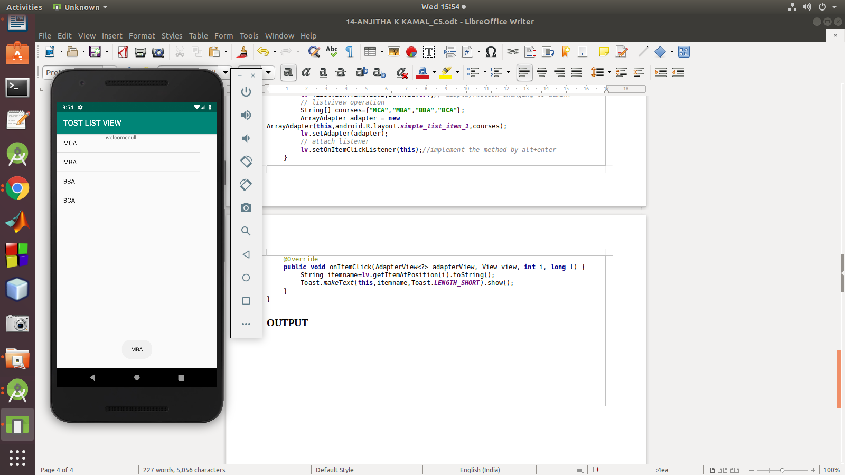

Q6:GRID VIEW
PROGRAM
Activity_main.xml
<?xml version="1.0" encoding="utf-8"?>
<android.support.constraint.ConstraintLayout
xmlns:android="http://schemas.android.com/apk/res/android"
xmlns:tools="http://schemas.android.com/tools"
xmlns:app="http://schemas.android.com/apk/res-auto"
android:layout_width="match_parent"
android:layout_height="match_parent"
tools:context=".MainActivity">
<GridView
android:id="@+id/gv"
android:layout_width="wrap_content"
android:layout_height="wrap_content"
android:columnWidth="100dp"
android:minHeight="100dp"
android:numColumns="auto_fit"
android:stretchMode="columnWidth"
app:layout_constraintBottom_toBottomOf="parent"
app:layout_constraintLeft_toLeftOf="parent"
app:layout_constraintRight_toRightOf="parent"
app:layout_constraintTop_toTopOf="parent" />
</android.support.constraint.ConstraintLayout>
Main_Activity.java
package com.example.sjcet.myapplication;
import android.support.v7.app.AppCompatActivity;
import android.os.Bundle;
import android.view.View;
import android.widget.AdapterView;
import android.widget.ArrayAdapter;
import android.widget.GridView;
import android.widget.Toast;
public class MainActivity extends AppCompatActivity implements AdapterView.OnItemClickListener {
GridView gridView;
static final String[] gridviewvalue={
"facebook","Instagram","YouTube",
"facebook","Instagram","YouTube",
"facebook","Instagram","YouTube"
};
@Override
protected void onCreate(Bundle savedInstanceState) {
super.onCreate(savedInstanceState);
setContentView(R.layout.activity_main);
gridView=findViewById(R.id.gv);
ArrayAdapter adapter = new ArrayAdapter(this,android.R.layout.simple_list_item_1,gridviewvalue);
gridView.setAdapter(adapter);
gridView.setOnItemClickListener(this);
}
public void onItemClick(AdapterView<?> adapterView, View view, int i, long l) {
String itemname=gridView.getItemAtPosition(i).toString();
Toast.makeText(this,itemname,Toast.LENGTH_SHORT).show();
}
}
OUTPUT
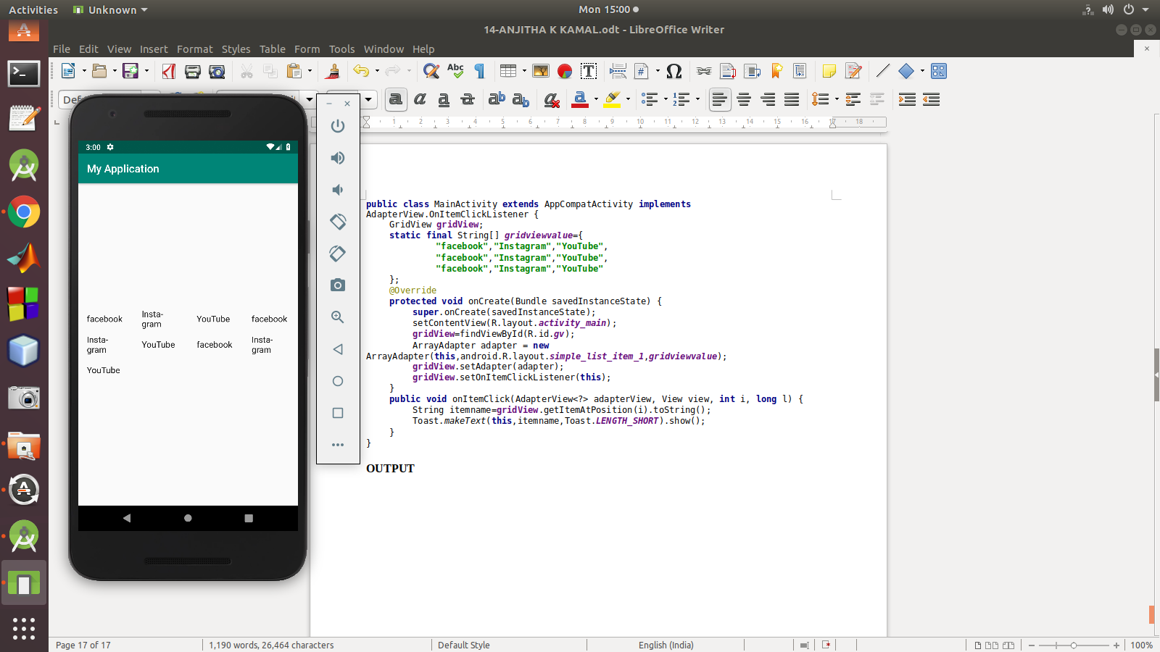

Q7:OPTION MENU

PROGRAM
Activity_Main.xml
<?xml version="1.0" encoding="utf-8"?>
<android.support.constraint.ConstraintLayout xmlns:android="http://schemas.android.com/apk/res/android"
xmlns:app="http://schemas.android.com/apk/res-auto"
xmlns:tools="http://schemas.android.com/tools"
android:layout_width="match_parent"
android:layout_height="match_parent"
tools:context=".MainActivity">
<TextView
android:layout_width="wrap_content"
android:layout_height="wrap_content"
android:text="Hello World!"
android:id="@+id/tv"
app:layout_constraintBottom_toBottomOf="parent"
app:layout_constraintLeft_toLeftOf="parent"
app:layout_constraintRight_toRightOf="parent"
app:layout_constraintTop_toTopOf="parent" />
</android.support.constraint.ConstraintLayout>
Main_Activity.java
package com.example.sjcet.contextmenu;
import android.support.v7.app.AppCompatActivity;
import android.os.Bundle;
import android.view.Menu;
import android.view.MenuItem;
import android.widget.TextView;
import android.widget.Toast;
public class MainActivity extends AppCompatActivity {
TextView tv;
@Override
protected void onCreate(Bundle savedInstanceState) {
super.onCreate(savedInstanceState);
setContentView(R.layout.activity_main);
tv=(TextView)findViewById(R.id.tv);
String msg=getIntent().getStringExtra("mykey");// receiving the data
tv.setText(msg); // display(welcom changing to admin)
}
@Override
public boolean onCreateOptionsMenu(Menu menu) {
getMenuInflater().inflate(R.menu.main_menu,menu); //connecting menu
return true; // changing to true
}
@Override
public boolean onOptionsItemSelected(MenuItem item) {
switch (item.getItemId()) {
case R.id.emergency: // full colon
Toast.makeText(this," Emergency clicked",Toast.LENGTH_SHORT).show();
break;
case R.id.profile:
Toast.makeText(this," Profile clicked",Toast.LENGTH_SHORT).show();
break;
case R.id.aboutus:
Toast.makeText(this," About us clicked",Toast.LENGTH_SHORT).show();
break;
case R.id.signout:
Toast.makeText(this," Signout clicked",Toast.LENGTH_SHORT).show();
break;
}
return true;// changing to true
}
}
Main_Menu.xml
<?xml version="1.0" encoding="utf-8"?>
<menu xmlns:android="http://schemas.android.com/apk/res/android">
<item
android:id="@+id/emergency"
android:title="Emergency clicked"/>
<item
android:id="@+id/profile"
android:title="Profile clicked"/>
<item
android:id="@+id/aboutus"
android:title="About us clicked"/>
<item
android:id="@+id/signout"
android:title="Signout clicked"/>
</menu>
OUTPUT

